Do Muslims have the right idea about the doctrine of the Trinity?
1. What is the Christian’s understanding of this doctrine?
In Matthew 28:18-20, Jesus tells His Disciples, “All authority in heaven and on earth has been given to me. Go therefore and make disciples of all nations, baptizing them in the name of the Father and of the Son and of the Holy Spirit, teaching them to observe all that I have commanded you. And behold, I am with you always, to the end of the age.” Much confusion surrounds the doctrine of the Trinity, especially coming from Islam.
It seems that a troubling area for many Muslims in discussing the doctrine of the Trinity is in logic. For instance, some Muslims wonder how three people can be one person, or how one being can be three beings, but this is not what Christians are saying. Trinitarian believers would also disagree with these statements and call them logical fallacies.
William Lane Craig, founder of Reasonable Faith, has something very interesting to say about this:
“The doctrine of the Trinity is not the doctrine that three Gods are somehow one God. That would be clearly self-contradictory – to say there are three Gods, and these are one God. Neither is it the claim that there are three persons who are somehow one person. That, again, would be self-contradictory – to assert that there are three persons who are all one person. But the doctrine of the Trinity does not assert that there are three Gods that are one God or three persons that are one person, but it asserts that there is one God who is tri-personal. It is one God who is three persons, or, to put it another way, there is one God who has three centers of self-consciousness: the Father, the Son, and the Holy Spirit.”
So, just like an individual person is one being with one center of self-consciousness, God is one being with three centers of self-consciousness.

2. What do Muslims believe about this doctrine?
Where does this confusion come from? In the Quran, in Sura 4:171 we find the following:
“O followers of the Book! Do not exceed the limits in your religion, and do not speak (lies) against Allah, but (speak) the truth; the Messiah, Isa son of Marium is only a messenger of Allah and His Word which He communicated to Marium and a spirit from Him; believe therefore in Allah and His messengers, and say not, Three…”
From this, it would appear that the author of this text believed that Jesus was not only not deity, but that Christians believe in three gods. From point 1., we can clearly see that this is incorrect, but this is what most Muslims seem to believe about the Trinity.
Also, in Sura 5:116 we find the following:
“And when Allah will say: O Isa son of Marium! did you say to men, Take me and my mother for two gods besides Allah he will say: Glory be to Thee, it did not befit me that I should say what I had no right to (say); if I had said it, Thou wouldst indeed have known it; Thou knowest what is in my mind, and I do not know what is in Thy mind, surely Thou art the great Knower of the unseen things.”²
Here the Quran teaches that Christians believe that the Trinity is three gods again, with Mary being one of them. This is, as discussed already, completely false. So then, does Allah not understand what Christians believe? Or does he understand and is deceiving?

3. How does the Bible critique Islam’s approach to this doctrine?

God is one (Deuteronomy 6:4)
Yet He exists in three persons: Father, Son, and Holy Spirit (John 10:30; Acts 5:1-4).

God is three in persons and one in essence. The Bible teaches this. For instance, in Deuteronomy 6:4, “Hear O Israel, the Lord your God the Lord is one.” One can also see biblically, that God exists in three persons. Let’s look at John chapter ten, verses 30-33… Jesus replies, “‘I and the Father are one.’ The Jews picked up stones again to stone him. Jesus answered them, ‘I have shown you many good works from the Father; for which of them are you going to stone me?’ The Jews answered him, ‘It is not for a good work that we are going to stone you but for blasphemy, because you, being a man, make yourself God.’”
The Jews at this time recognized the fact that if Jesus were not who He said He was, this would indeed be blasphemy. The problem is that they were blind to see the truth of who He was through His miracles. The point is that the Jews picked up stones to stone Him because He was calling Himself God. The Jews clearly recognized this, which is why they wanted to stone Him for blasphemy. The question is, why wouldn’t we recognize today that Jesus called Himself God? Perhaps it is because of blindness in our day as well.
In the book of Acts, 5:1-4, Dr. Luke records what took place:
“But a man named Ananias, with his wife Sapphira, sold a piece of property, and with his wife’s knowledge he kept back for himself some of the proceeds and brought only a part of it and laid it at the apostles’ feet. But Peter said, “Ananias, why has Satan filled your heart to lie to the Holy Spirit and to keep back for yourself part of the proceeds of the land? While it remained unsold, did it not remain your own? And after it was sold, was it not at your disposal? Why is it that you have contrived this deed in your heart? You have not lied to man but to God.”
In this passage, Peter, who is not just an early Christian, but is also an Apostle of Christ, calls the Holy Spirit “God.” Why would people not want to describe God the way the Early Church does? Perhaps it is because those who do not want to acknowledge the Trinity are so far removed from the early church that it is an extreme distinction from the early church.
4. How can the biblical critique be used in order to build a bridge with Islam?
Jesus is more than just a prophet. He is more than just a messenger. Jesus claimed to be God, and lived a life proving to be such through His miracles. He did the things that God did in the Old Testament. God gave His people manna, Jesus fed the 4000 and 5000; God, through His prophet raised people from the dead, Jesus raised people from the dead; God healed the infertility of Sarah, Jesus healed many; God forgave sins, Jesus forgives sins (Mark 2).
It seems that some comparisons (like the three parts to an egg, equal an egg. Or the three states of water, are like the Trinity, etc.), are fallacious because they are concrete objects. Therefore, perhaps an abstract object might be a better illustration. For example, the internet is one thing, yet is many things. Explain to them that websites are all the “internet” yet they are their own website. When you are on Facebook, aren't you on the internet? When you are on Wikipedia, aren't you also on the internet? Yet in either case, you are also on one website. With this in mind and with the discussion material of this paper, one may perhaps see that the doctrine of the Trinity is not illogical, but is completely logical.

For Further Study:
The Guide to Answering Islam, by Daniel Janosik.
The Wisdom of Islam and the Foolishness of Christianity, by Richard Shumack
Islam and Christianity, by James F. Gauss
https://apologeticsandevidence.blogspot.com/

(Permission is granted to make copies of this pamphlet and to distribute them, provided this is done free of Charge and without altering the content.)

Defending Christianity Against Muslims

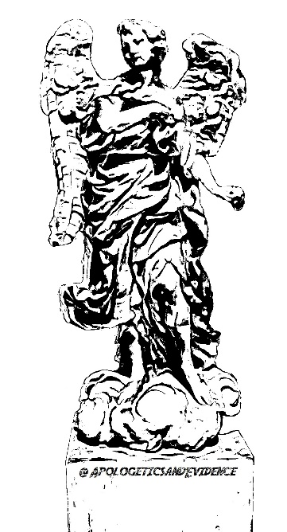

“Contend for the faith that was once
for all delivered to the saints.”
~Jude 3

@ApologeticsandEvidence

William Lane Craig, “Doctrine of the Trinity (part 1).” Reasonable Faith, June 27, 2011. https://www.reasonablefaith.org/podcasts/defenders-podcast-series-2/s2-doctrine-of-god-trinity/doctrine-of-the-trinity-part-1.
M. H. Shakir, ed., The Quran (Medford, MA: Perseus Digital Library, n. d.).

